GUI Email Client

🖼️ What Is a GUI Email Client?
# Source: AI Source: Provided by: [Data Path: Persons Table -> ID Column: 1, Name_En Column: Motasem Essam] -> From: [ChatGPT] on [1/21/2026]
A GUI (Graphical User Interface) email client is an application with a visual interface that allows users to send, receive, read, and organize emails using windows, buttons, icons, and menus — instead of command-line commands.
These clients are designed for ease of use, offering drag-and-drop features, visual email formatting, and integrations with calendars, contacts, and other apps.

🧰 Common GUI Email Clients
# Source: AI Source: Provided by: [Data Path: Persons Table -> ID Column: 1, Name_En Column: Motasem Essam] -> From: [ChatGPT] on [1/21/2026]
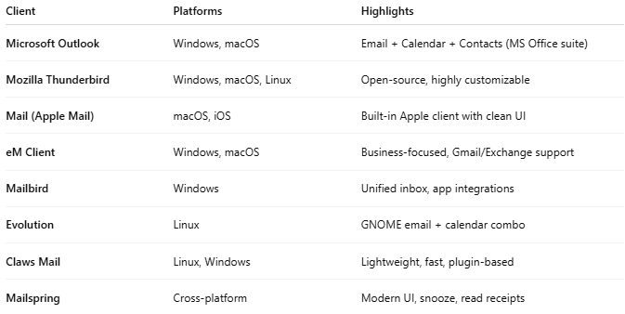

Client | Platforms | Highlights
Microsoft Outlook | Windows, macOS | Email + Calendar + Contacts (MS Office suite)
Mozilla Thunderbird | Windows, macOS, Linux | Open-source, highly customizable
Mail (Apple Mail) | macOS, iOS | Built-in Apple client with clean UI
eM Client | Windows, macOS | Business-focused, Gmail/Exchange support
Mailbird | Windows | Unified inbox, app integrations
Evolution | Linux | GNOME email + calendar combo
Claws Mail | Linux, Windows | Lightweight, fast, plugin-based
Mailspring | Cross-platform | Modern UI, snooze, read receipts

🧠 What GUI Clients Can Do
# Source: AI Source: Provided by: [Data Path: Persons Table -> ID Column: 1, Name_En Column: Motasem Essam] -> From: [ChatGPT] on [1/21/2026]
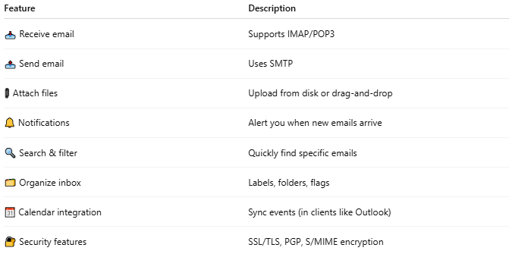

Feature | Description
📥 Receive email | Supports IMAP/POP3
📤 Send email | Uses SMTP
📎 Attach files | Upload from disk or drag-and-drop
🔔 Notifications | Alert you when new emails arrive
🔍 Search & filter | Quickly find specific emails
🗂️ Organize inbox | Labels, folders, flags
📆 Calendar integration | Sync events (in clients like Outlook)
🔐 Security features | SSL/TLS, PGP, S/MIME encryption

🔁 GUI vs CLI (Command-Line) Clients
# Source: AI Source: Provided by: [Data Path: Persons Table -> ID Column: 1, Name_En Column: Motasem Essam] -> From: [ChatGPT] on [1/21/2026]
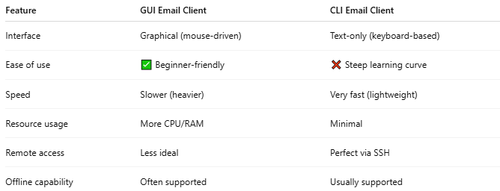

Feature | GUI Email Client | CLI Email Client
Interface | Graphical (mouse-driven) | Text-only (keyboard-based)
Ease of use | ✅ Beginner-friendly | ❌ Steep learning curve
Speed | Slower (heavier) | Very fast (lightweight)
Resource usage | More CPU/RAM | Minimal
Remote access | Less ideal | Perfect via SSH
Offline capability | Often supported | Usually supported

✅ Summary
# Source: AI Source: Provided by: [Data Path: Persons Table -> ID Column: 1, Name_En Column: Motasem Essam] -> From: [ChatGPT] on [1/21/2026]
A GUI email client is a user-friendly program that lets you manage your email using a graphical interface with buttons, windows, and icons.
It's ideal for everyday users who prefer visual tools and want features like drag-and-drop, calendar sync, and rich formatting.

